10/7/2008

|  |
| --- |
| ForcePAD 2.4 | JonasLindemann |

# 

|  |  |
| --- | --- |
| Lund University | ForcePAD Manual |

# Introduction

ForcePAD is a sketch program for material shape and form. Using the program structures can be easily drawn and analysed with regards to applied forces and constraints. The design of the program is based on the same conceptual model as image editing applications such as Microsoft Paint, Adobe Photoshop, Paint.NET or The GIMP. Structures are drawn using pens and other drawing tools. Forces can be places by simple clicks with the mouse. Constraints are placed in the same way as forces. Stresses and displacements are also calculated and visualized quickly without any delays.

# Installation

## System requirements

|  |  |  |
| --- | --- | --- |
|  | **Windows** | **Mac OS X** |
|  |  |  |
| **Operating system** | Windows XP  Windows Vista  Windows 7 | Mac OS X 10.4, 10.5 eller 10.6 with an Intel based processor |
| **CPU** | Intel Pentium 4 or higher. | Intel Pentium 4 or higher. |
| **Memory** | At least 512 Mb | At least 512 Mb |
| **Harddrive** | 4 Mb installed, 1 Gb or more to run larger models. | 4 Mb installed, 1 Gb or more to run larger models. |
| **Graphics** | Hardware accelerated OpenGL graphics. | Hardware accelerated OpenGL graphics. |

## Windows

Download the installation package from <http://forcepad.sourceforge.net>.

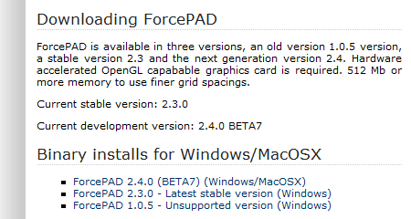

Figure – Donwload page on forcepad.sourceforge.net

Click on ForcePAD 2.4.x to get the latest version. A new page is shown in the web browser.

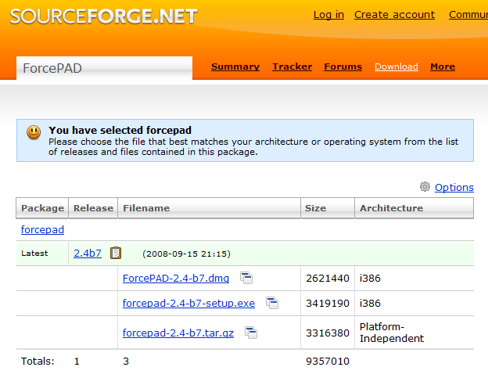

Figure 2 – Sourceforge installation package selection

The installation package for Windows is the file with the extension .exe. Click on the link to download the package. After a couple of seconds a dialog box is shown with a request to save the installation package fil.

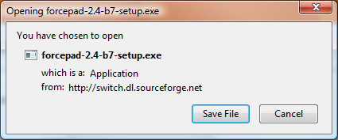

Figure 3 – Dialogbox for saving installation package

Click on **Save File** to save the file on the local hard drive. The installation package can then be started by double clicking on the downloaded file.

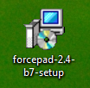

Figur 4 – Icon for the ForcePAD installation package

Follow the instructions to finish the installation. After a successful installation ForcePAD can be started from the start menu by selecting it from the start menu group “Structural Mechanics” and selecting “ForcePAD 2”.

## Mac OS X

# ForcePAD main window

ForcePAD uses a task oriented user interface, which means that the user interface adapts to the task at hand. The left toolbar in the main window contains the main task categories. The right toolbar shows the main tasks and their related properties.



Figur - ForcePADs programfönster

To reduce user interface clutter, ForcePAD operates in three main modes:

* **Sketch mode** - In this mode the analysed structure is defined by sketching using the available drawing tools.
* **Physics mode** – In this mode the physical boundary conditions, such as loads and constraints, for the analysed structure are defined.
* **Result mode** – In this mode the forces and structure deflections can be visualized and analysed.

Switching between the modes is accomplished by using the mode switch buttons located in the lower right corner of the window.

# Sketch mode

In sketch mode the analysed structure is created by drawing with stiffness. Black color denotes full stiffness and white color no stiffness. To create structures, paint tools used in normal image editing applications can be used, such as pens with different sizes, lines, rectangles, circles and flood fills. In this section these tools are described detail with examples how they are used.

## Drawing with stiffness

The easiest way to create structures is to use the pen tools. To use this tool, select the pen task in the left toolbar (1). When this task category is chosen the available tasks are shown in the right toolbar (2).



Fiure 6 – Choice of drawing tools

When the pen task category is chosen for the first time the a pen with 100 % stiffness is preselected in the task toolbar. Drawing is done by moving the cursor over the drawing area holding the left mouse button down. As long as the left mouse button is down the pen will leave a trace with the selected stiffness and pen thickness. Figure 7 illustrates the process of drawing using the pen tool.



Figure 7 – Using the pen tool

The eraser tool is used in the same way as the pen tool with the difference that it will use 0 % stiffness.

Stiffness can be choses by clicking on the grayscale buttons in the property toolbar. Black is 100% stiffness white is no stiffness.

Pen thickness is chosen by clicking on the 5 circles in the property toolbar on the right. The size of the circles corresponds roughly to pen size when drawing. Figure 8 – shows the property menu for the drawing tools.



Figure 8 - Drawing tools propery toolbar

## Filling surfaces and holes

A common operation in image editing application is to fill closed surfaces with colors. In ForcePAD this is done using the floodfill tool. The tool is found in the left toolbar. Figure 9 shows were the flood fill tool is located in ForcePAD.



Figure 9 – Flood fill tool

A surface is filled by selecting the stiffness in the property toolbar and then clicking with the left mouse button in the middle of the surface. The cross in the cursor denotes where the flood fill tool will start the fill process. Figure 10 illustrates the use of the fill tool.



Figure 10 – Using the fill tool

## Geometric tools

To draw geometric shapes there is a special task category for this purpose in ForcePAD. Figure 11 shows the tools in this category.



Figure 11 – Geometric tools

### Rectangle tool

Rectangles with different stiffness can be created using the rectangle tool. A rectangle is created by selecting the starting point with the left mouse button, moving the mouse with the mouse button down, releasing it at the endpoint of the rectangle. Figure 12 illustrates this process.



Figure 12 – Creating rectangles with the rectangle tool

### Circle tool

Using the circle tool, circles and ellipses can be quickly created. A circle is created by selecting the starting point with the left mouse button, moving the mouse with the mouse button down, releasing it at the endpoint of the circle. Figure 13 illustrates this process.



Figure 13 – Creating circles with the circle tool

### Line tool

Using the line tool lines with varying thickness can be created. A line is created by selecting the starting point with the left mouse button, moving the mouse with the mouse button down, releasing it at the endpoint of the line. Figure 14 illustrates this concept.



Figure 14 – Creating lines with the line tool

## Using the grid

To create more exact drawings, ForcePAD can activate a drawing grid. The grid is activated by selecting **Settings/Snap to Grid** in the menu. The grid can also be activated temporarily by using the [⇧/Shift] key. The grid has the same spacing as the calculation grid. Changing the grid spacing can be done in the calculation settings dialog found in the **Settings/Calculation…** menu.

## Cut, Copy and Paste

When editing an image it is often needed to copy or move data in the image. ForcePAD supports a basic clipboard that can be used to accomplish this. To use the clipboard the selection task category must be selected from the right toolbar as shown in Figure 15.



Figure - Selection tools in ForcePAD

To copy or move objects in the image, the selection tool is used to select the object. A selection is placed by clicking on the start point, holding the left mouse button down and moving the mouse to the end point of the selection, finally releasing the button. Figure 16 illustrates this process.



Figure - Creating a selection with the selection tool

When the selection is placed the other tools in this task category can be used.

### Copy

The copy tool will copy the pixels in the selection box to the ForcePAD clipboard as shown in Figure 17.



Figure - Copying pixels from selection box to the clipboard

### Cut

The cut tool copies the pixels in the selection box to the clipboard while replacing the pixels on the drawing area with white (no stiffness). The process is shown in



Figur - Using the cut tool to move pixels from the selection box to the clipboard

### Paste

Using the paste tool the pixels copied to the clipboard can be pasted back into the image. When the paste tool is selected the copied image in the clipboard appears under the cursor and can be moved over the image. The image is copied to the drawing by clicking on the left mouse button. Multiple copies to the image can be done by repeated clicking on the mouse button.



Figur - ForcePAD Paste tool operation

## Expanding the drawing surface fit the window

When resizing the ForcePAD window the drawing surface is not automatically resized. To do this, first click on the selection tools button then click on the expand workspace button in the right toolbar, see figure 20

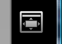

Figure - Expand workspace button

The existing image will be copied to the expanded workspace placed in the lower left corner, as shown in figure 21.



Figure - Expanding the workspace

# Physics mode

In physics mode the forces and constraints can be placed on the model. Placement of forces and constrains are a two click process. In principle set the position and rotation.

## Creating forces

A force is created by clicking on the position in the structure where it is acting ➀. While holding the mouse button down the direction of the force can be changed by moving the mouse around the force application position ➁-➂. Figure 22 illustrates the process of creating a force.



Figure - Creating forces

## Creating constraints

A constraint is created by clicking on the position in the structure where it is acting ➀. While holding the mouse button down the direction of the constraint can be changed by moving the mouse around the constraint application position ➁-➂. Figure 23 illustrates the process of creating a constraint.



Figure - Creating constraints

## Ange egenvikt

## Ange dimensioner och tjocklek

# Beräkningsinställningar

## Upplösning

## Beräkningskonstanter

## Randvillkor

# Resultatläge - Action mode

## Visa huvudspänningar

## Visa von Mises spänningar

## Visa deformationer

## Uppdatera placering och riktning av krafter

# Strukturoptimering

# Exempel på användning

## Balk på två stöd

## Fackverk

## Cykel